Software Design & Specification Document

– Beat Stomper

Stefan Yuzhao Heng, Kevin Jianxiang Gao

Tues. Aug. 29th 2017

# Product

## Idea

* The *Beat Stomper* on cell phones
  + 
  + Idea like *Temple Run*: To survive and score
  + Move a block as planks fall

# Process

## Design

### Idea

* Canvas
  + 16:9
* 3 Planks bouncing & 1 Block jumping
  + 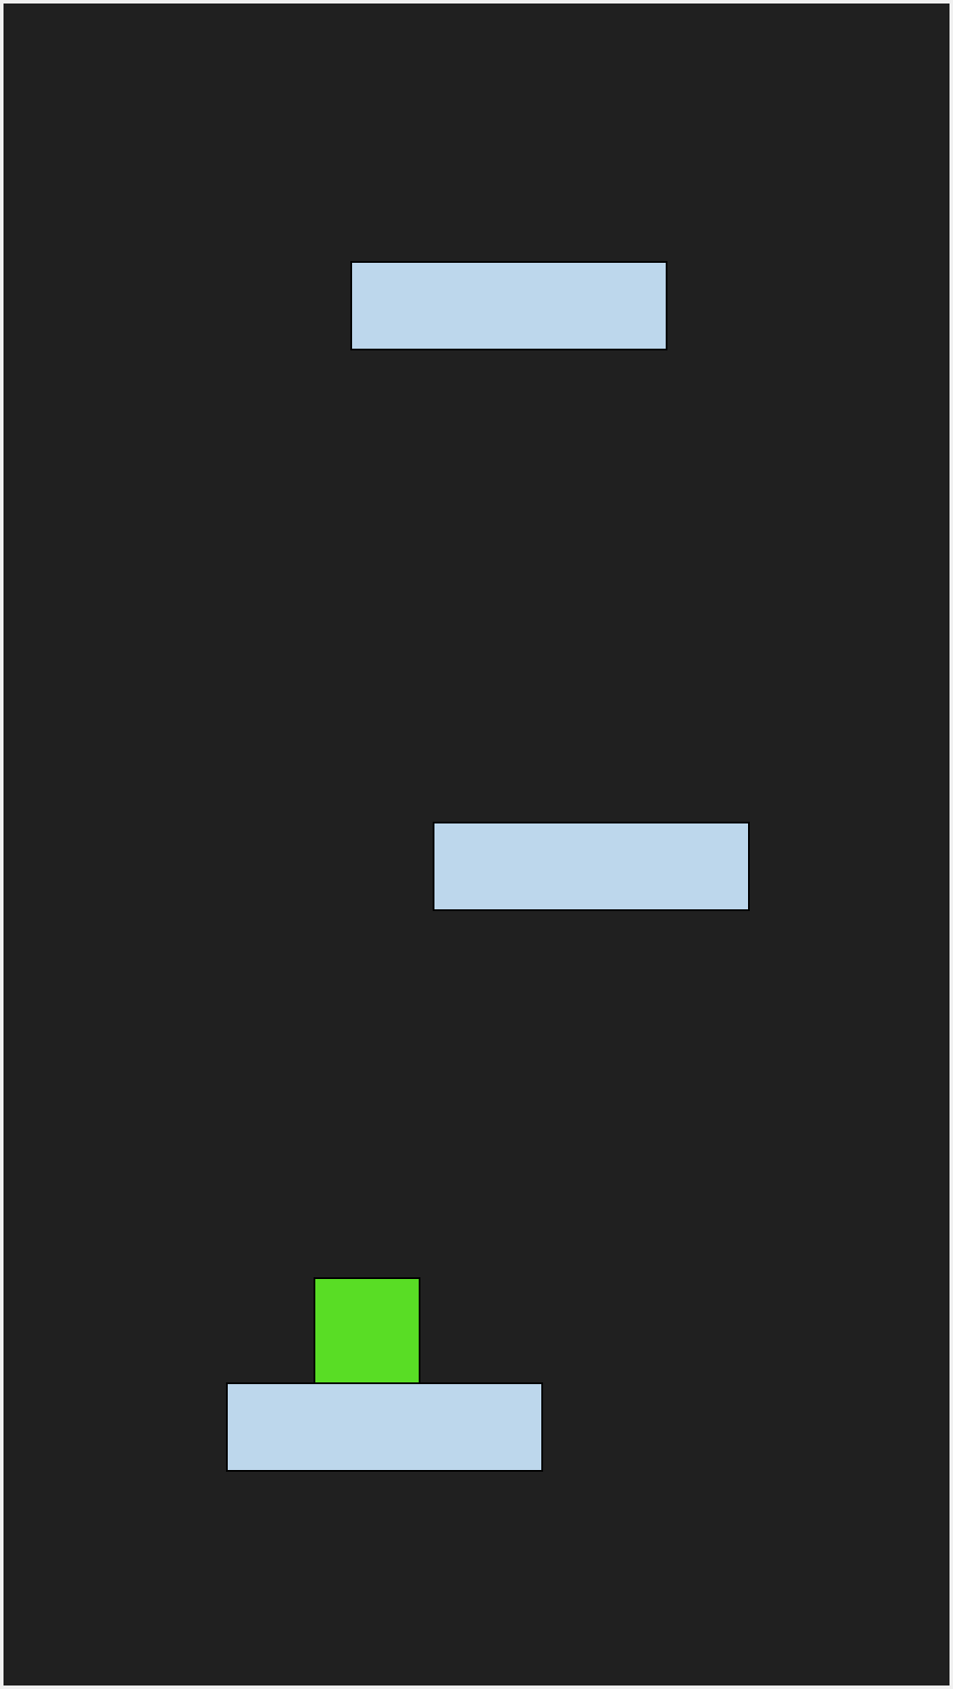
* Constantly rising difficulty
  + 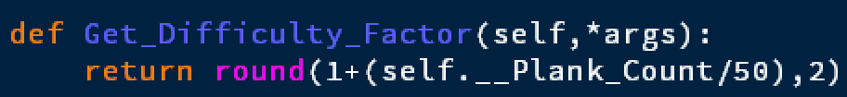
* Pause, Restart and Record breaking
* Music

### Details

* Plank width, Block shape
  + 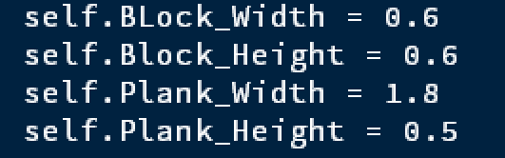
* Arrays to store location & speed
  + 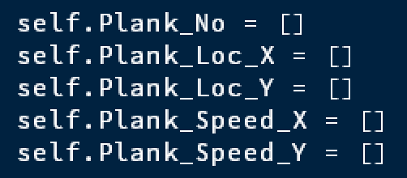
* Plank starts at random position from top
* Jump movement
  + Accelerate downwards at all time
  + 1st press: also move horizontally
  + 2nd press: fall straight down
  + Move parallel with on plank
  + Move faster horizontally on air
* Booleans for 1st or 2nd jump
  + 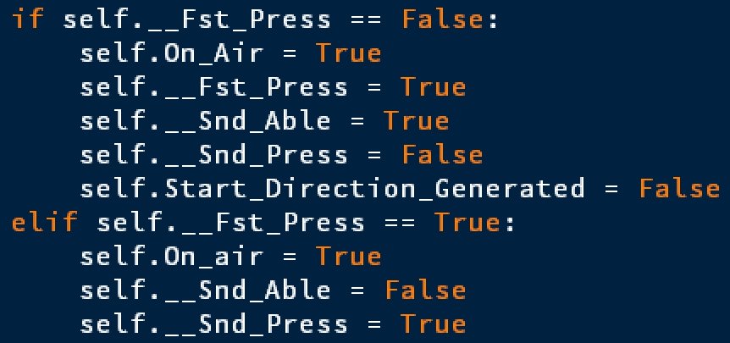

## Coding

* TKInter for GUI
  + No extra installation
  + 
* Class and *self.*
  + 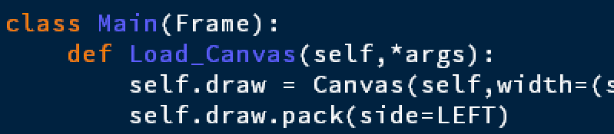
* Frame refreshing
  + 
* Move plank as speed

Move block as plank or own function

* Jump
  + The delta each frame increases linearly
    - 
  + 2nd press
    - Falls downwards no matter what
    - 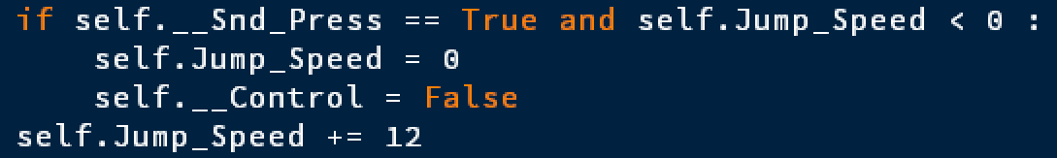
* Event for key and mouse input
  + 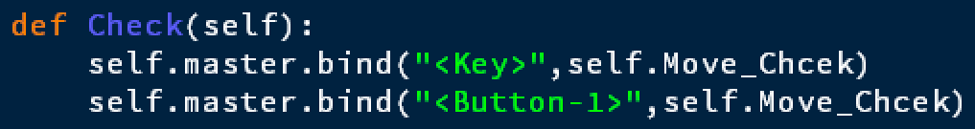
  + 
* Function *move* 
  + 
* Label & place()
  + 
* Restart variables
  + 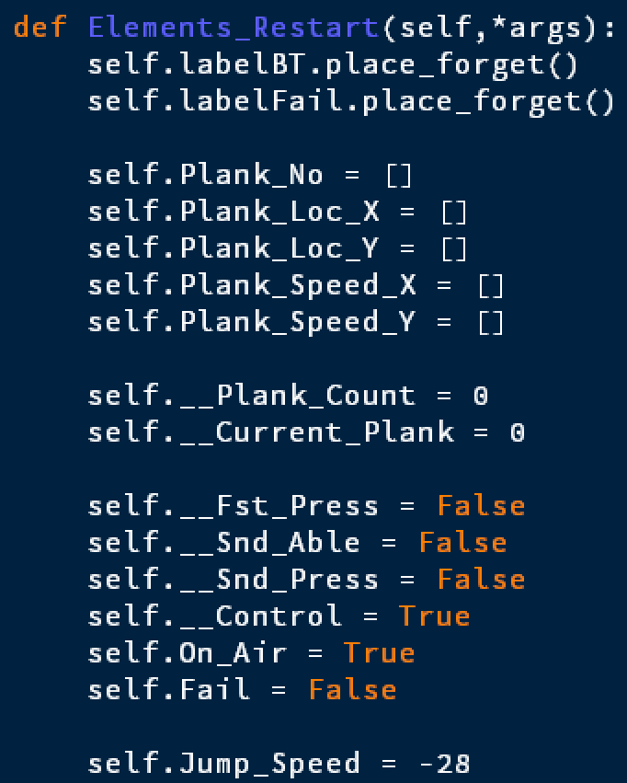
* Formatting & Generalization
  + 960 → self.Scaling * self.Canvas_Width
  + 
  + 
* Better control when coding
  + 

## Testing

* Stub Testing
  + 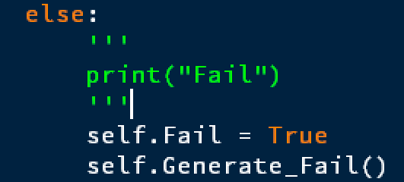
* Black-Box Testing
* Record each bug-free version
  + 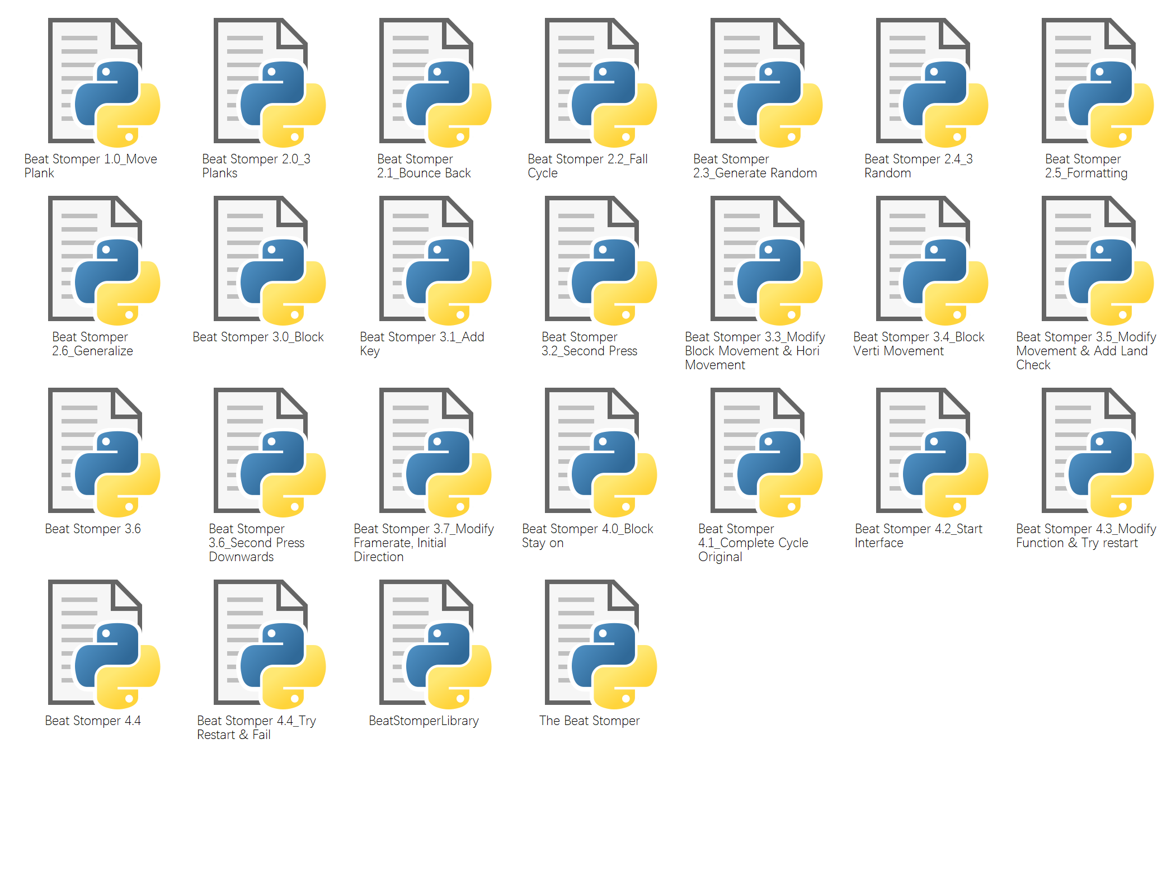

# Reflections & Improvements

* Reflection
  + Start earlier when you can; you never know how much time debug could take
  + For codes, it’s not *the longer, the better*
  + Its’ not simple as adding *self.*
  + Always remember to save your library after change
* Improvements
  + Gradually changing background color
  + Background music
  + History record
    - File
  + User settings
    - Define Difficulty